Zumbrota Dance Studio Apparel Order Form
Order forms due December 1; Pick up December 17

Name: ________________________________________________________________

Phone: _______________________________________________________________

Email: ________________________________________________________________

ITEM | Size | Quantity
30th Anniversary Tee

Purple Tee with White Logo

Grey Hooded Logo Sweatshirt

White/Purple Baseball Tee
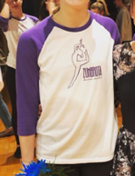

Tank Top

Black ZDS Baseball Hat

