Zumbrota Dance Studio Water Bottle Order Form
Order forms due January 31; Pick up TBD

Name: ________________________________________________________________

Phone: _______________________________________________________________

Email: ________________________________________________________________

ITEM | Price | Quantity
25oz Aluminum Bike Bottle  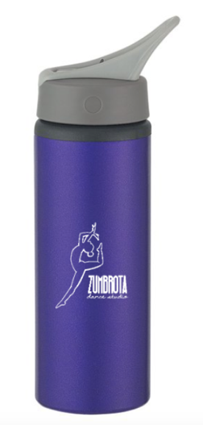 | $12
With 4-inch vinyl name decal | $15 | Name on bottle:

