DANCE RECITAL MAY 21 & 22ND
The following flowers can be prebooked by either contacting us @ 507-732-5599, messaging us via facebook, zumbrotaflowersonmain or email; flowersonmain345@hotmail.com Payments can be made via credit card, when you call or via PayPal –paypal.me/Brenda Lerum, **when using paypal, (please use the friends & family option, or paypal takes a percentage of the amount)
You are also welcome to stop in and place your order and pay with cash or check. Please use the following form as a guideline to place your order.
We will be selling flowers 1 hour prior to each performance and may have other floral options available. All prebooked orders will be delivered prior to each performance, but can be left at the table to be picked up later. Each order will be labeled with dancers name.
************All preorders must be placed by May 18th*********************
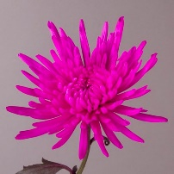#1 Fuji Bouquets-3 bright colored fuji mums-----------$10.00
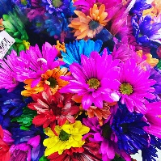#2 Neon Daisies-Bouquet of bright colored daisies-----$15.00
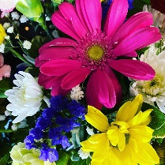#3 Tropical Splash Bouquet-bright mixed colorful flowers--$20.00
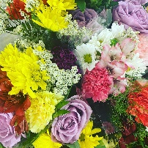#4 Dancer Bouquet—pastel colored bouquet w/ gerberas--$25.00
Mylar Balloons-- $6.00 A--smiley face B---Unicorn
C---You crushed it/way to go D--Candy Bag----$5.00

Dance Recital Order Form

Dancer’s Name______________________________________________________
Grade/Age_________________________
Performance----Saturday 4:30___________________________________
Sunday 1:30____________________________ 4:30__________________________
Bouquet--#1______________________________#2_____________________________
#3______________________________#4_____________________________
Balloons—A______________________B______________________C_______________
Candy-----D___________________

(one order form per performance) Payment________________

Dance Recital Order Form

Dancer’s Name______________________________________________________
Grade/Age_________________________
Performance----Saturday 4:30___________________________________
Sunday 1:30____________________________ 4:30__________________________
Bouquet--#1______________________________#2_____________________________
#3______________________________#4_____________________________
Balloons—A______________________B______________________C_______________
Candy-----D___________________

(one order form per performance) Payment________________________

